Enterprise Risk Management Analytics

A Competitive Risk Assessment of American Express During the EMV Chip Transition

Course: ALY6130

Risk Management Analytics

Institution: Northeastern University

Term: Winter 2026

Git hub repo : https://github.com/Aryanbansal1785/AmexChipTransition_RiskAssessment/tree/main/enterprise-risk-project

Background
American Express is one of the world's largest financial services companies, operating a closed-loop payment network that serves millions of cardholders and merchants globally. Unlike Visa and Mastercard, which operate open-loop networks where banks issue cards independently, American Express controls both the card issuance and the payment network itself. This structural difference gives American Express greater control over its products and customer relationships but also creates unique operational and competitive challenges when the payment industry undergoes major technological change.
In 2015, the United States payment industry began transitioning to EMV chip card technology following a fraud liability shift policy established by the four major card networks including American Express, Visa, Mastercard, and Discover. The liability shift, which became effective in October 2015, changed how financial responsibility for fraudulent transactions was assigned. Before the shift, card-issuing banks generally absorbed the cost of most fraudulent transactions. After the shift, if a merchant accepted a fraudulent transaction at a terminal that had not been upgraded to accept EMV chip cards, the merchant became liable for the financial loss rather than the card issuer (Pape, 2025).
The purpose of the transition was to reduce counterfeit card fraud, which had been a growing problem in the United States. Countries that had already completed the EMV transition, including the United Kingdom and Canada, saw significant reductions in card-present fraud following their transitions. The United States was one of the last major economies to adopt EMV technology, making it an attractive target for fraudsters who had been displaced from other markets.
While the transition successfully reduced card-present fraud, it introduced a new set of competitive, financial, and legal risks for American Express. Because American Express operates a closed-loop network, its EMV terminal certification process was more complex and time-consuming than the open-loop certification processes used by Visa and Mastercard. This meant that many merchants faced longer delays in getting their American Express terminals certified, even after completing their Visa and Mastercard certifications. As a result, a growing number of merchants were able to accept chip cards from Visa and Mastercard but not from American Express, creating a widening merchant acceptance gap (Fitzgerald, 2016).
At the same time, the transition created a new and growing fraud risk. As EMV technology secured in-store card-present transactions, fraudsters shifted their activity to online card-not-present channels where chip technology provides no protection. This shift exposed American Express to a rising volume of online fraud losses, particularly given its premium high-spending cardholder base which represented a more attractive target for sophisticated fraud operations.
The legal and regulatory environment added further complexity. In March 2016, a group of merchants led by Florida retailer B&R Supermarket filed a class action lawsuit against American Express, Visa, Mastercard, and Discover, alleging that the four networks had conspired to implement the fraud liability shift using nearly identical rules effective on the same date, in violation of federal and state antitrust laws. American Express ultimately settled its portion of the lawsuit for $20 million as part of a combined settlement totaling $231.7 million across all four networks (Pape, 2025).
This report presents a comprehensive enterprise risk management assessment of American Express during the EMV chip transition. The assessment identifies three competitive risks, evaluates their likelihood and impact using both qualitative and quantitative analytics techniques, develops risk response strategies, and establishes Key Risk Indicators to support ongoing risk monitoring. The analysis draws on the COSO Enterprise Risk Management framework, the Indicators and Warning analysis technique, machine learning classification, and Monte Carlo simulation to provide a rigorous and evidence-based assessment of the risks facing American Express during this period of significant industry change.

Identification of Risks
The risk identification process for this assessment began with a SWOT analysis of American Express during the EMV chip transition. The SWOT analysis examined the internal strengths and weaknesses of American Express as well as the external opportunities and threats created by the transition. This structured approach ensured that risks were identified from both an internal operational perspective and an external competitive perspective, consistent with the COSO Enterprise Risk Management framework which requires organizations to consider both internal and external factors when identifying risks (COSO, 2017).
The SWOT analysis identified several key findings. On the internal side, American Express had significant strengths including its closed-loop network control, its global experience with EMV in international markets, and its Fraud Liability Shift policy which protected cardholders while encouraging merchant upgrades. However, the same closed-loop structure that gave American Express control also created weaknesses, including a more complex and slower terminal certification process compared to Visa and Mastercard, higher merchant fees that made smaller merchants less willing to prioritize American Express acceptance, and vulnerability to card-not-present fraud that the EMV chip technology could not address.
On the external side, the transition created opportunities through the development of Express pay, American Express's EMV-based contactless payment solution, and the growing demand for faster and more convenient payment methods. However, it also introduced significant threats including the competitive advantage gained by Visa and Mastercard through their faster open-loop terminal deployments, the rise of card-not-present fraud as fraudsters shifted to online channels, and the antitrust litigation risk from merchants who alleged the liability shift was imposed unfairly.
From this SWOT analysis, three competitive risks were identified as the highest priority concerns for American Express during the EMV transition. These risks were selected because they represented the most direct threats to American Express's competitive position, financial performance, and legal standing in the marketplace.

Risk 1
Card-Not-Present (CNP) Fraud (Financial Risk)
The risk of escalating financial losses from card-not-present fraud, caused by EMV chip technology eliminating card-present counterfeit fraud and redirecting fraudsters to unprotected online and phone-based channels, resulting in increased chargeback costs, fraud-related operational expenses, and erosion of cardholder trust among American Express's premium customer segment. This risk was assigned a likelihood score of 7 out of 9 and an impact score of 8 out of 9, producing a risk score of 56 and a HIGH priority classification.

Risk 2
Merchant Terminal Certification Delays (Operational Risk)
The risk of merchant EMV terminal certification being delayed due to American Express's proprietary closed-loop certification process being more complex than the open-loop systems used by Visa and Mastercard, resulting in merchants being exposed to fraud liability during certification gaps and reduced American Express in-person acceptance during the transition period. This risk was assigned a likelihood score of 7 out of 9 and an impact score of 6 out of 9, producing a risk score of 42 and a MEDIUM priority classification.

Risk 3
Merchant Acceptance Loss to Competitors (Competitive Risk)
The risk that American Express loses merchant acceptance share to Visa and Mastercard during the EMV rollout, caused by Visa and Mastercard's open-loop networks enabling faster and broader terminal upgrades at scale, resulting in cardholders experiencing American Express declines at non-certified merchants and potential cardholder attrition to competing networks. This risk was assigned a likelihood score of 9 out of 9 and an impact score of 8 out of 9, producing a risk score of 72 and a HIGH priority classification. This is the highest priority risk in the assessment.
In addition to these three priority risks, the full risk register documented three additional risks including reputational risk from publicly reported fraud incidents during the transition window, legal and compliance risk from antitrust litigation brought by merchants, and a second operational risk related to EMV-certified terminals failing to process transactions correctly. These risks received MEDIUM priority classifications and are documented in full in Appendix 1.

Qualitative Risk Assessment
The qualitative risk assessment evaluated each of the six identified risks using scenario analytics and industry fusion analytics to determine their likelihood and impact prior to any quantitative modeling. This two-step approach is consistent with best practice in enterprise risk management, which recommends starting with qualitative methods to prioritize risks before applying more resource-intensive quantitative techniques (Fleisher and Bensoussan, 2015).

Scenario Analytics
Scenario analytics was applied to each risk by asking structured "what if" questions about how each risk could materialize under different conditions. For the CNP fraud risk, the scenario considered was: what if fraudsters shifted their full attention to online channels following the EMV transition? Based on the experience of other countries that had already completed EMV transitions, evidence suggested that card-not-present fraud consistently increased in the years following EMV adoption as criminals adapted their methods. The United Kingdom, for example, saw a significant rise in online fraud following its EMV transition, a pattern that was widely expected to repeat in the United States (EMV Connection, n.d.). This scenario supported a high likelihood and high impact classification for this risk.
For the merchant acceptance risk, the scenario considered was: what if Visa and Mastercard completed their terminal certifications significantly faster than American Express? Given the structural difference between open-loop and closed-loop certification processes, this scenario was assessed as very likely. Terminal manufacturers Verifone and Ingenico both reported slower than expected demand for American Express terminal upgrades specifically, which confirmed the scenario was already beginning to materialize at the time of assessment (Fitzgerald, 2016). This scenario supported a maximum likelihood score of 9 and a high impact score of 8 for this risk.
For the terminal certification delay risk, the scenario considered was: what if smaller merchants chose to deprioritize American Express certification due to higher fees and certification complexity? Given that American Express charges higher merchant fees than Visa and Mastercard, this scenario was assessed as somewhat likely, particularly among small and medium-sized businesses with limited resources for terminal upgrades.

Industry Fusion Analytics
Industry fusion analytics was applied by examining the EMV transition experiences of other countries and drawing lessons that were relevant to the American Express situation in the United States. The United Kingdom completed its EMV transition approximately a decade before the United States and documented a clear pattern in which card-present fraud declined sharply while card-not-present fraud rose significantly in the years following the transition. This international evidence provided strong support for classifying CNP fraud as a high priority risk for American Express, as the same pattern was highly likely to emerge in the United States market.
The experience of other payment networks during the U.S. transition also informed the competitive risk assessment. Visa and Mastercard's open-loop networks allowed them to certify terminals through a decentralized process involving thousands of acquiring banks and independent sales organizations, which was significantly faster than American Express's centralized closed-loop process. This structural advantage was confirmed by industry reporting which showed that large merchants completed chip upgrades with Visa and Mastercard well ahead of their American Express certifications (Fitzgerald, 2016).
Risk Scoring and Prioritization
Each risk was scored using a standardized risk calculation sheet with likelihood scores on a scale of 1 to 9 and impact scores on a scale of 1 to 9. The risk score was calculated by multiplying the likelihood score by the impact score, producing a maximum possible score of 81. Threshold definitions were established as follows: scores from 54 to 81 were classified as HIGH priority, scores from 27 to 53 were classified as MEDIUM priority, and scores from 1 to 26 were classified as LOW priority.

The risk scoring results are summarized in the table below:
Risk # | Risk Type | Likelihood | Impact | Risk Score | Priority
R-001 | Financial | 7 | 8 | 56 | HIGH
R-002 | Operational | 7 | 6 | 42 | MEDIUM
R-003 | Competitive | 9 | 8 | 72 | HIGH
R-004 | Reputational | 5 | 8 | 40 | MEDIUM
R-005 | Legal/Compliance | 7 | 6 | 42 | MEDIUM
R-006 | Operational | 7 | 6 | 42 | MEDIUM

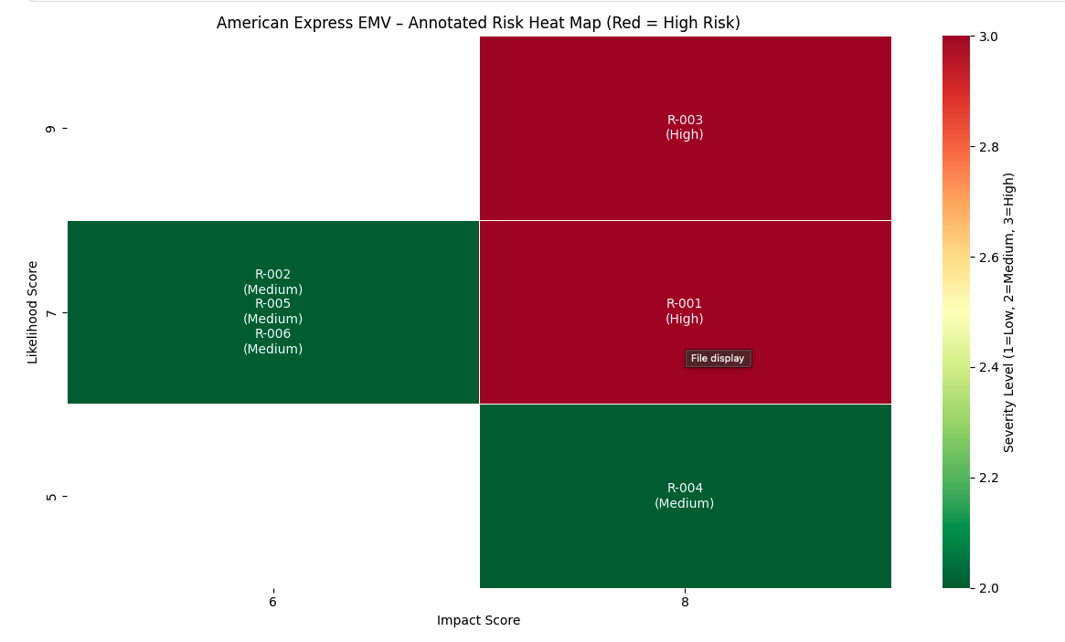
The risk heat map produced from this scoring confirmed that R-003 and R-001 sat firmly in the red high-risk zone, while R-002, R-004, R-005, and R-006 sat in the yellow medium-risk zone. No risks fell in the green low-risk zone, indicating a consistently elevated risk environment for American Express during the EMV transition period.
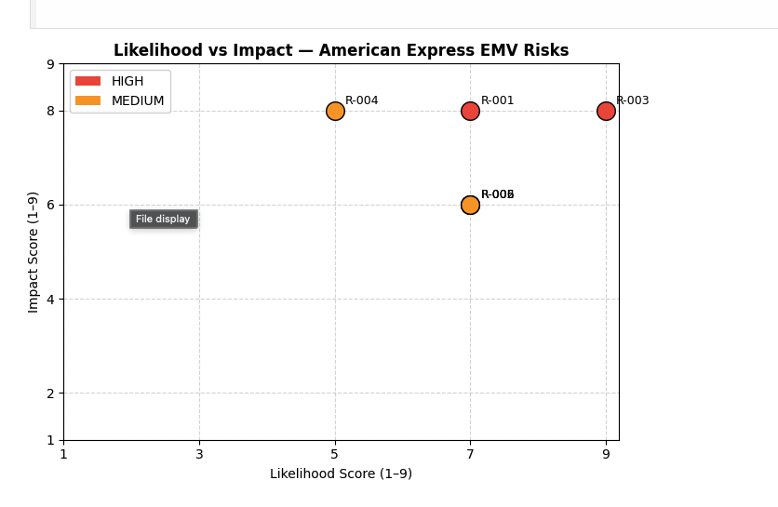
A Random Forest machine learning classifier was also applied to the risk register data to validate the severity classifications. Using two-fold cross-validation due to the small dataset size, the model correctly classified all four medium-severity risks and one of the two high-severity risks, achieving a mean accuracy of approximately 0.83. The qualitative heat map and the machine learning model produced consistent priority rankings, providing additional confidence in the severity classifications.

Quantitative Risk Assessment
Building on the qualitative risk assessment, quantitative analytics techniques were applied to the three priority risks to determine their probability and expected impact in numerical terms. This section presents the results of four quantitative methods: statistical estimation of probability and expected impact, machine learning based risk prediction using a Random Forest classifier, Monte Carlo simulation, and an integrated situation assessment connecting the business and non-business environments to the risk model inputs.
Statistical Estimation of Probability and Expected Impact
The likelihood scores from the risk register were converted to probability percentages by dividing each score by the maximum possible score of 9 and multiplying by 100. The impact scores were normalized to a zero to one scale using the same method. Expected impact was then calculated by multiplying the probability by the normalized impact value, producing a measure of overall risk severity that combines both dimensions into a single number.

The results for all six risks are presented in the table below:
Risk # | Risk Type | Probability (%) | Expected Impact
R-001 | Financial | 77.78% | 0.6914
R-002 | Operational | 77.78% | 0.5185
R-003 | Competitive | 100.00% | 0.8889
R-004 | Reputational | 55.56% | 0.4938
R-005 | Legal/Compliance | 77.78% | 0.5185
R-006 | Operational | 77.78% | 0.5185

R-003 had the highest expected impact of 0.8889, reflecting its maximum likelihood score and high impact score. R-001 had the second highest expected impact of 0.6914, followed by R-002 at 0.5185. These results are consistent with the qualitative risk priority ranking and provide a numerical foundation for the Monte Carlo simulation.

ML-Based Risk Prediction
A Random Forest classifier was trained on the risk register data to predict the severity classification of each risk based on its likelihood and impact scores. Random Forest was selected because it is a robust ensemble learning method that performs well on small datasets and provides interpretable outputs that are directly useful for risk management decision making.
The model used likelihood score and impact score as the two input features, which correspond directly to the Key Risk Indicators identified for each risk. Two-fold cross-validation was applied due to the small size of the dataset. The model achieved a mean cross-validation accuracy of approximately 0.83, correctly classifying all four medium-severity risks and one of the two high-severity risks.
Feature importance analysis confirmed that impact score was the stronger predictor of severity classification, followed by likelihood score. This finding is consistent with the risk management principle that the potential consequence of a risk is generally a more important driver of priority than the probability of occurrence alone.

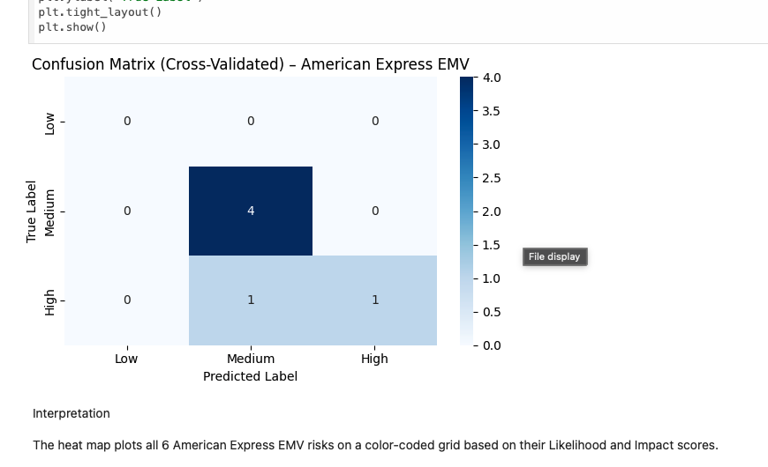

Monte Carlo Simulation
Monte Carlo simulation was applied to the three priority risks to model uncertainty and variability in risk outcomes. The simulation ran 10,000 random scenarios for each risk by drawing probability and impact values from a normal distribution centered on the calculated values from the statistical estimation step. A standard deviation of 0.05 was applied to each parameter to reflect real-world uncertainty around the estimates. The simulated values were clipped between zero and one to maintain realistic bounds, and the final risk score for each scenario was scaled back to the original one to eighty-one range used in the risk register.
The simulation results are summarized in the table below:
Risk | Mean Score | Median Score | Best Case (5th Pct) | Worst Case (95th Pct)
R-003 Competitive | 70.56 | 70.62 | 62.14 | 77.81
R-001 Financial | 56.02 | 56.05 | 48.91 | 64.03
R-002 Operational | 41.94 | 41.96 | 35.82 | 48.93

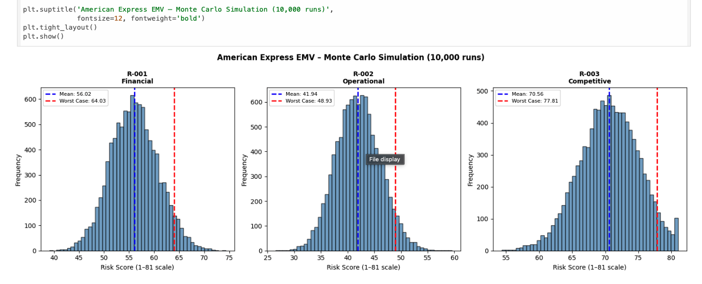
The simulation results confirmed the priority ranking established in the qualitative assessment. R-003 had the highest mean simulated score of 70.56, which aligns closely with its qualitative score of 72. Even in the best case scenario at the fifth percentile, R-003 produced a score of 62.14, which remains well within the HIGH risk zone. R-001 produced a mean score of 56.02 with a worst case of 64.03, both firmly in the HIGH zone. R-002 produced a mean score of 41.94 with a worst case of 48.93, which approaches the HIGH threshold of 54 under adverse conditions.

Integrated Situation Assessment
The quantitative risk model inputs were informed by both the business environment and the non-business environment surrounding American Express during the EMV transition.
From the business environment perspective, the competitive landscape between American Express, Visa, and Mastercard was the primary driver of the merchant acceptance risk inputs. Visa and Mastercard's structural advantage through open-loop networks allowed them to deploy terminals faster and more broadly, which directly informed the maximum likelihood score of 9 assigned to R-003. The financial environment, including the rising volume of online transactions and the growing sophistication of fraud operations, informed the high probability and impact scores assigned to R-001.
From the non-business environment perspective, several factors influenced the risk model inputs. The regulatory environment created by the fraud liability shift policy directly increased the probability of merchant litigation, which was reflected in the HIGH likelihood score assigned to R-005. The technological environment, specifically the rapid growth of mobile payments and contactless technology, informed the competitive risk inputs by establishing the pace at which consumer payment habits were evolving. The geopolitical environment, including the international experience of EMV transitions in the United Kingdom and other markets, provided the benchmarks used in the industry fusion analytics to validate the probability and impact estimates for CNP fraud.

Risk Response Strategy
Risk response strategies were developed for each of the three priority risks based on the qualitative and quantitative assessment results. The response strategies follow the PMI risk response framework which distinguishes between strategies for negative risks and strategies for positive risks or opportunities (PMI, 2017).
Risk 1 R-001: Card-Not-Present (CNP) Fraud (Financial Risk, Score 56, HIGH)
Response Strategy: Mitigate
CNP fraud was classified as a HIGH priority negative risk requiring an active mitigation strategy. Acceptance was ruled out because the financial losses from rising CNP fraud chargebacks posed a direct and ongoing threat to American Express's revenue and premium brand reputation. Transfer through insurance was considered but deemed insufficient as a standalone response because it would address financial losses after the fact without reducing the underlying fraud exposure. Avoidance was not a realistic option because American Express could not exit the online payments market.
The mitigation strategy centers on investing in AI-driven fraud detection systems capable of identifying suspicious online transaction patterns in real time. American Express should deploy tokenization and 3D Secure authentication for all online transactions to add an additional layer of verification beyond the card number. Multi-factor authentication should be required for high-value transactions above a defined threshold. These controls directly address the root cause of the risk by making it significantly harder for fraudsters to complete unauthorized online transactions even after obtaining card details.
From an internal environment perspective, American Express has existing data analytics capabilities and a large transaction dataset that can be used to train machine learning fraud detection models. From an external environment perspective, the regulatory environment increasingly requires strong customer authentication for online payments, which aligns with the mitigation strategy and provides additional justification for investment in these controls.
Risk 2 R-002: Merchant Terminal Certification Delays (Operational Risk, Score 42, MEDIUM)
Response Strategy: Mitigate with Monitoring
Terminal certification delays were classified as a MEDIUM priority negative risk. While the risk does not require the same level of immediate action as the HIGH priority risks, the Monte Carlo simulation showed that under adverse conditions this risk could approach the HIGH threshold of 54. For this reason a passive acceptance strategy was rejected in favor of active mitigation combined with close KRI monitoring.
The mitigation strategy focuses on streamlining the American Express closed-loop certification process to reduce the time and complexity merchants face when upgrading their terminals. This includes deploying dedicated merchant support teams to assist with the certification process, offering financial incentives to merchants who complete certification within a defined timeframe, and working with payment terminal manufacturers to develop simplified certification pathways for smaller merchants. American Express should also leverage its Expresspay contactless platform and Quick Chip technology to provide merchants with faster and less complex upgrade options.
From an internal environment perspective, American Express has strong relationships with its merchant network and the financial resources to fund merchant incentive programs. From an external environment perspective, the competitive pressure from Visa and Mastercard's faster deployment creates urgency for American Express to close the certification gap as quickly as possible.
Risk 3 R-003: Merchant Acceptance Loss to Competitors (Competitive Risk, Score 72, HIGH)
Response Strategy: Mitigate and Exploit
Merchant acceptance loss was classified as the highest priority risk in the assessment. This risk requires the most urgent and comprehensive response. However, it also contains elements of a positive risk because the growing demand for contactless and mobile payments creates a significant opening for American Express to differentiate itself through Express pay and mobile wallet integration.
The mitigation component of the response strategy focuses on accelerating Expresspay merchant enrollment, partnering with payment acquirers to speed up terminal deployments, and launching targeted campaigns to educate merchants about the benefits of accepting American Express.
The exploit component involves capitalizing on the growing contactless payment opportunity by deepening integration with Apple Pay and Google Pay, launching cardholder awareness campaigns promoting contactless payment options, and positioning Express pay as a premium contactless solution. This dual approach directly addresses the competitive threat while simultaneously capturing the opportunity created by the shift in consumer payment preferences.
From an internal environment perspective, American Express's premium brand positioning and loyal high-spending cardholder base provide a strong foundation for differentiating its contactless offering. From an external environment perspective, the rapid growth of mobile wallets and contactless payments globally creates a favorable market environment for investment in this area.

Key Risk Indicators and Trigger Points
Key Risk Indicators were developed for each of the three priority risks to provide American Express management with early warning signals that a risk is increasing before it becomes a critical issue. Each KRI was developed following the six phases of the CRISP-DM framework to ensure that the indicator was grounded in a clear understanding of the business problem, supported by relevant data, and connected to actionable risk response protocols.

CRISP-DM Framework Applied to KRI Development
The CRISP-DM framework consists of six phases: Business Understanding, Data Understanding, Data Preparation, Modeling, Evaluation, and Deployment. For each KRI, this framework was applied as follows. In the Business Understanding phase, the specific competitive risk was defined and the business objective of the KRI was established. In the Data Understanding phase, the data sources available to measure the indicator were identified. In the Data Preparation phase, the relevant data was organized and cleaned to support consistent measurement. In the Modeling phase, the Random Forest classifier and Monte Carlo simulation were used to validate the relationship between the indicator and the risk severity. In the Evaluation phase, the threshold values were tested against the quantitative model outputs to ensure they would trigger action at the right point. In the Deployment phase, the KRI was integrated into the risk monitoring process with assigned ownership and defined escalation protocols.

KRI 1 Monthly Card-Not-Present Fraud Rate (R-001, Financial Risk)
Definition: The percentage of total online transactions flagged as fraudulent in a given month.
Basis for Development: This KRI was selected because CNP fraud is a direct and measurable consequence of the EMV transition. The CRISP-DM data understanding phase identified American Express's internal transaction monitoring systems as the primary data source for this indicator. The Monte Carlo simulation confirmed that under worst case conditions the financial risk score could reach 64.03, which supports the need for a sensitive early warning indicator that triggers action before losses reach that level.

Level | Threshold | Management Action
Green | CNP fraud rate below 0.1% | Risk within normal tolerance, no action required
Amber | CNP fraud rate between 0.1% and 0.3% | Review fraud detection algorithms, strengthen authentication requirements, increase monitoring frequency
Red | CNP fraud rate above 0.3% | Immediate escalation to Chief Risk Officer, activate fraud response plan, notify affected cardholders, conduct root cause analysis

Risk Owner: Chief Risk Officer

KRI 2 Monthly Merchant Acceptance Rate (R-002, Operational Risk)
Definition: The percentage of U.S. merchants accepting American Express compared to Visa and Mastercard coverage.
Basis for Development: This KRI was selected because the merchant acceptance gap is the most direct and observable indicator of the terminal certification delay risk. The CRISP-DM data understanding phase identified industry payment acceptance data and American Express's internal merchant network tracking systems as the primary data sources. The Monte Carlo simulation showed that under worst case conditions this risk approaches the HIGH threshold of 54, which supports the need for amber-level intervention before the gap widens beyond a recoverable point.

Level | Threshold | Management Action
Green | Amex acceptance rate above 85% of Visa and Mastercard coverage | Risk within normal tolerance, continue current certification support programs
Amber | Acceptance rate drops to between 75% and 85% | Activate merchant outreach program, offer terminal upgrade incentives, streamline certification requirements for small merchants
Red | Acceptance rate falls below 75% | Immediate escalation to Chief Commercial Officer, launch emergency merchant acquisition campaign, engage payment acquirers for accelerated deployment support

Risk Owner: Chief Commercial Officer

KRI 3 — Monthly Contactless and Mobile Payment Transaction Growth Rate (R-003, Competitive Risk)
Definition: The month-over-month percentage growth in Expresspay and mobile wallet transactions processed through American Express.
Basis for Development: This KRI was selected because the contactless payment growth rate measures both the competitive threat and the opportunity embedded in R-003. A declining growth rate signals that American Express is losing ground in the fastest-growing segment of the payments market. The CRISP-DM data understanding phase identified American Express's internal transaction processing systems and mobile wallet partnership data as the primary sources. The Monte Carlo simulation produced a mean score of 70.56 for this risk with a worst case of 77.81, approaching the maximum possible score of 81. This extreme severity level justifies a highly sensitive KRI with narrow thresholds that trigger early intervention.

Level | Threshold | Management Action
Green | Month-over-month growth above 5% | Opportunity being captured effectively, continue Expresspay enrollment and mobile wallet campaigns
Amber | Growth rate between 2% and 5% | Review merchant enablement strategy, strengthen Apple Pay and Google Pay integration incentives, launch targeted cardholder awareness campaigns
Red | Growth rate below 2% or declining | Immediate escalation to Chief Digital Officer, activate strategic review of Expresspay positioning, accelerate merchant enrollment and mobile wallet partnerships

Risk Owner: Chief Digital Officer

Conclusion
This report presented a comprehensive enterprise risk management assessment of American Express during the EMV chip card transition in the United States. The assessment followed the full risk management lifecycle from risk identification through qualitative assessment, quantitative modeling, risk response planning, and KRI development, consistent with the COSO Enterprise Risk Management framework.
Three competitive risks were identified as the highest priorities. The merchant acceptance loss risk scored 72 and was classified as the most critical risk in the entire assessment, driven by Visa and Mastercard's structural advantage through open-loop networks that allowed faster terminal deployment across the U.S. merchant base. The CNP fraud risk scored 56 and represented a direct consequence of the EMV transition pushing fraudsters from card-present to unprotected online channels. The terminal certification delay risk scored 42 but the Monte Carlo simulation showed it could approach the HIGH threshold of 54 under adverse conditions, making it a risk that requires active monitoring rather than passive acceptance.
The quantitative analysis using the Random Forest classifier and Monte Carlo simulation with 10,000 runs confirmed and strengthened the priority rankings from the qualitative assessment. The mean simulated scores of 70.56 for merchant acceptance, 56.02 for CNP fraud, and 41.94 for terminal delays were consistent with the qualitative risk scores, providing strong evidence that the risk prioritization was accurate and well grounded.
The risk response strategies developed for each priority risk were tailored to the severity and nature of the risk. CNP fraud required a mitigation strategy centered on AI-driven fraud detection and strong online authentication. Terminal certification delays required a mitigate with monitoring approach using merchant incentives and certification process improvements. Merchant acceptance loss required both a mitigation and an exploit strategy that addressed the competitive threat while capitalizing on the contactless payment opportunity.
The KRIs established for each risk provide American Express management with clear, measurable early warning signals and defined escalation protocols that support proactive risk management rather than reactive issue management. Together, these elements provide a solid foundation for American Express to navigate the risks of the EMV transition and protect its competitive position in the U.S. payments market.

References
COSO. (2017). Enterprise risk management: Integrating with strategy and performance. Committee of Sponsoring Organizations of the Treadway Commission. https://www.coso.org/guidance-erm
EMV Connection. (n.d.). EMV migration driven by payment brand milestones. https://www.emv-connection.com/emv-migration-driven-by-payment-brand-milestones/
Fitzgerald, K. (2016). Why EMV failed to meet terminal makers' expectations. American Banker. https://www.americanbanker.com/payments/news/why-emv-failed-to-meet-terminal-makers-expectations
Fleisher, C. S., & Bensoussan, B. E. (2015). Business and competitive analysis: Effective application of new and classic methods (2nd ed.). Pearson Education.
Jalilvand, A., & Moorthy, S. (2023). Triangulating risk profile and risk assessment: A case study of implementing enterprise risk management system. Journal of Risk and Financial Management, 16(11), 473. https://doi.org/10.3390/jrfm16110473
Pape, C. (2025). Visa, Mastercard settle merchant suit for nearly $200M. American Banker. https://www.americanbanker.com/payments/news/visa-mastercard-settle-merchant-suit-for-nearly-200m
PMI. (2017). A guide to the project management body of knowledge (PMBOK Guide) (6th ed.). Project Management Institute.

Appendix 1: Complete Risk Treatment and Response Plan
The complete Risk Treatment and Response Plan including the full risk register, risk calculation sheet, risk heat map, and KRI summary is provided in the accompanying Excel file titled RiskManagement_updated.xlsx. This file contains all six identified risks with their likelihood scores, impact scores, risk scores, priority classifications, mitigation strategies, risk owners, and KRI thresholds as documented throughout this assessment.
